Handling Events

## addEventListener

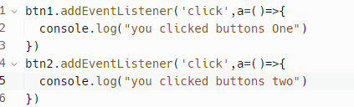

removeEventListener();

//to make removeEventListener work you’ll have to give the refrence of the same function object

This line is the most important in the addEventListener Topic

Eg

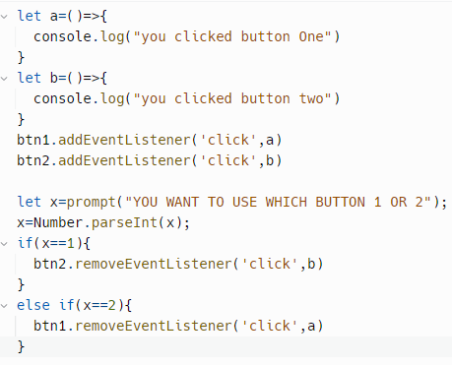

When you’ll select 1 , button two won’t work

When you’ll select 2, button one won’t work

Changing random page background

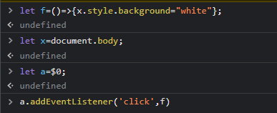

## e.target;

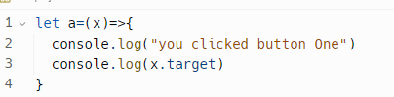

To get that button

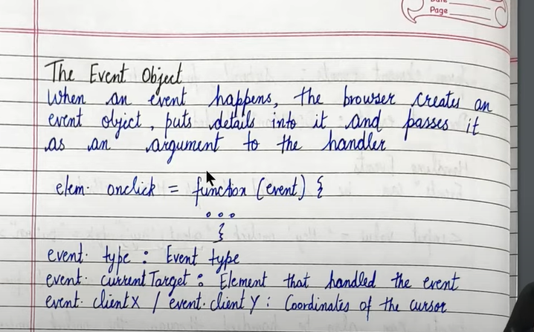yehi bat likhihui hai //target or current target both are sem// currentTarget means ke kis element ne handle kia hai iss event ko